1.1P: Preparing for OOP – Answer Sheet

# Introduction

This paper’s answer sheet serves two purposes:

1. It serves as a revision for you of your previous learnings; and
2. It establishes a baseline understanding of your knowledge in key Computer Science topics.

As such this paper is divided into the following areas of knowledge:

1. Your experience with UNIX/DOS console commands;
2. Your ability to differentiate between data types (e.g. text) and information categories (e.g. title);
3. Your experience with compiler parsing and evaluation of expressions according to rules of precedence (e.g. BODMAS, also known as GEMS or PEMDAS);
4. Your understanding of Computer Science concepts and various compiler constructs such as blocks and scope;
5. Finally taking three steps, we want you to develop a program as follows:
   1. starting with a simple function: you provide the pure logic and calculations, no input, nor output;
   2. Then, in the second step, you write the main line code that invokes that simple function. Your main line code will provide the necessary data, and then you will print out the result of the function’s calculation.
   3. Finally we want you to add business logic to the main line program’s code; that business logic will interpret the results of the function, and inform your user with information about the results.

## Section A: Console commands

1. Explain the following terminal instructions:

1. cd: *is used to change the current working directory in various operating systems*
2. pwd: *is used to find the path of the current folder, the one that you are in*
3. mkdir: *is used to create a new folder*
4. cat: *is used to view file content on standard output* ***sdout***
5. ls: *is used to list the contents of a directory, showing all files and subdirectories contained inside.*

## Section B: Data types and Information categories

1. Consider the following categories of information, and suggest the most appropriate data type to store and represent each kind of information:

|  |  |
| --- | --- |
| **Information Category** | **Suggested Data Type** |
| A person’s family name | string |
| A person’s age in years | integer |
| A person's weight in Kilograms | float |
| A telephone number | integer |
| A temperature on the Kelvin scale | float |
| The average age of a group of children | float |
| Whether the student passed this task | boolean |

1. Aside from the examples already provided above, please come up with your own examples of information that could be stored as:

|  |  |
| --- | --- |
| **Data Type** | **Suggested Information Category** |
| String | My name |
| Integer | My age |
| Float | My weight |
| Boolean | Whether I’m going to pass this subject |

**Section C: Compiler evaluation of expressions**

1. Fill out the **last** two columns of the following table based on the expression and values we have supplied.
2. Evaluate the value of each expression under column 1, given its formula, values, and variables; use the given values (column 2) of any variable(s) in the expression.
3. Identify the value of the results (column 3), and the data type the result is most likely to be (column 4) in a compiler “friendly” form (e.g. Float):

|  |  |  |  |
| --- | --- | --- | --- |
| **Expression** | **Given** | **Result** | **Data Type** |
| 76 |  | 76 | Integer |
| True |  | True | Boolean |
| a | a = 3.1415927 | 3.1415927 | Float |
| 1 + 2 * 3 + 4 |  | 11 | Integer |
| a and False | a = True | False | Boolean |
| a or False | a = True | True | Boolean |
| a + b | a = 1 b = 3 | 4 | Integer |
| 3 * a | a = 5 | 15 | Integer |
| a * 2 + b | 1. = 2.5 2. = 3 | 8.0 | Float |
| a + 2 * b | 1. = 2.5 2. = 3 | 8.5 | Float |
| (a + b) * c | a = 2 b = 4 c = 6 | 36 | Integer |
| “Fred” + “ Astair” |  | Fred Astair | String |
| a + “ Rogers” | a = “Ginger” | Ginger Rogers | String |

**Section D: Compiler Constructs and CS Concepts:**

1. Using some code as an example, please explain the difference between **declaring** and **initialising** a variable.

The difference between the two *is:*

* *Declaring means introducing the variable to the program by providing its name and type*
* *Intialising means assigning it an initial value*

*Paste your example code below:* *int capybara;*

*capybara = 5;*

1. Explain the term **parameter**. Write some **code** that demonstrates a simple of use of a parameter. You should show a procedure or function that uses a parameter, and how you would call that procedure or function. A parameter *is used in a function to represent the value that is passed into the function.*

*Paste your example code below:*

*class Hi  
{  
 static void sayhi(string name)  
 {  
 Console.WriteLine("Hello, " + name + ".");  
 }  
}*

1. Using an **coding example**, describe the term **scope** as it is used in procedural programming (not in business nor project management). Make sure you explain the differences of as many kinds of scope that you can identify (at least two, and up to five).

Scope is *the context in which a variable or function is accessible in a program which defines the visibility and lifetime of variables and functions within different parts of the code.*

Global scope: variables declared outside of any function or block and can be accessed from anywhere in the program.

Local scope: variables declared inside a function and can be accessed within the function.

Block scope: variables declared inside a block and can be accessed within that block.

*Paste your example code below:*

*Global scope:*

*class Hi  
{*

*static string globalVariable = "Wren";*

*static void sayhi(string name)  
 {  
 Console.WriteLine("Hello, " + globalVariable + ".");  
 }  
}*

*Local scope:*

*class Hi  
{  
 static void sayhi(string name)  
 {*

*static string localVariable = "Wren";  
 Console.WriteLine("Hello, " + localVariable + ".");  
 }  
}*

## Section E: Implementing Algorithms, Data Handling, and Informing Results - Personalized Requirements

**STEP 1:**

1. In a procedural style, in any language you prefer, write a function called Average, which accepts an array of integers, and returns the average of those integers.
2. **Do not use any libraries for calculating the average**: we want to see your understanding of algorithms.
3. You must demonstrate appropriate use of parameters, returning and assigning values, and the use of loop(s). **Note — just write the function at this point.** In the next step we will ask you to ***invoke the function.***
4. You should **not** have a complete program, **nor** even code that outputs anything at this stage. This is a **function**; and input/output and any business logic processing is the responsibility of the (main line) calling code.

*Paste your example function code below:*

*def average (arr)*

*sum = 0*

*count = arr.length*

*i = 0*

*while i < count*

*sum += arr[i]*

*i += 1*

*end*

*return sum.to_f / count*

*end*

**STEP 2:**

1. Using the same preferred language, write the main line calling code you would need to (a) marshal the data, (b) invoke the function, (c) print out the result, and (d) **print out your student name and student Id**
2. We do **not** require you to provide any input processing logic; you simply have provide the inline instantiate of a collection of data values (provided below) for the function to calculate the average of that data set.

a. Sample data values

2.5, -1.4, -7.2, -11.7, -13.5, -13.5, -14.9, -15.2, -14.0, -9.7, -2.6, 2.1 7. Note: your should have made **no changes** to your function.

*Paste all of your example code below:*

*def average (arr)*

*sum = 0*

*count = arr.length*

*i = 0*

*while i < count*

*sum += arr[i]*

*i += 1*

*end*

*return sum.to_f / count*

*end*

*nums =* [2.5, -1.4, -7.2, -11.7, -13.5, -13.5, -14.9, -15.2, -14.0, -9.7, -2.6, 2.1]

*avg = average(nums)*

*puts " #{avg}"*

*puts ("Student Name: Uyen Giang Thai")*

*puts ("Student ID: 104828510")*

*Paste your example code’s output here:*

*-8.258333333333333*

*Student Name: Uyen Giang Thai*

*Student ID: 104828510*

1. Using the same preferred language, add to your existing mainline code above, the following business logic code for interpreting the result of the function’s calculations.
2. Print the message “Multiple digits” if the average is above or equal to 10. Otherwise, print the message “Single digits”.

10.And then, if the average is negative, add an additional line of output stating “Average value negative”.

11.Finally, if the last digit of the average is larger than the last digit of your Student ID, please print the message "**Larger than my last digit**". Otherwise, please print the correct message, either "**Equal to my last digit**" or "**Smaller than my last digit**".

12.Note, you should not have made any changes to your implemented function13.Provide evidence of your program running, i.e. the code, its environment, and its run time outputs.

*Paste your example code’s output here:*

*def average (arr)  
 sum = 0  
 count = arr.length  
 i = 0  
 while i < count  
 sum += arr[i]  
 i += 1  
 end  
 return sum.to_f / count  
end  
  
nums =* [2.5, -1.4, -7.2, -11.7, -13.5, -13.5, -14.9, -15.2, -14.0, -9.7, -2.6, 2.1] *avg = average(nums)  
puts " #{avg}"  
if avg >= 10  
 puts("Mutiple digits")  
else  
 puts("Single digits")  
end  
if avg < 0  
 puts("Average value negative")  
end  
puts ("Student Name: Uyen Giang Thai")  
id = 104828510  
puts ("Student ID: " + id.to_s)  
avg_output = avg.to_i % 10  
id_output = id[-1].to_i  
  
if id_output > avg_output  
 puts("Larger than my last digit")  
elsif id_output == avg_output  
 puts("Equal to my last digit")  
else id_output < avg_output  
 puts("Smaller than my last digit")  
end*

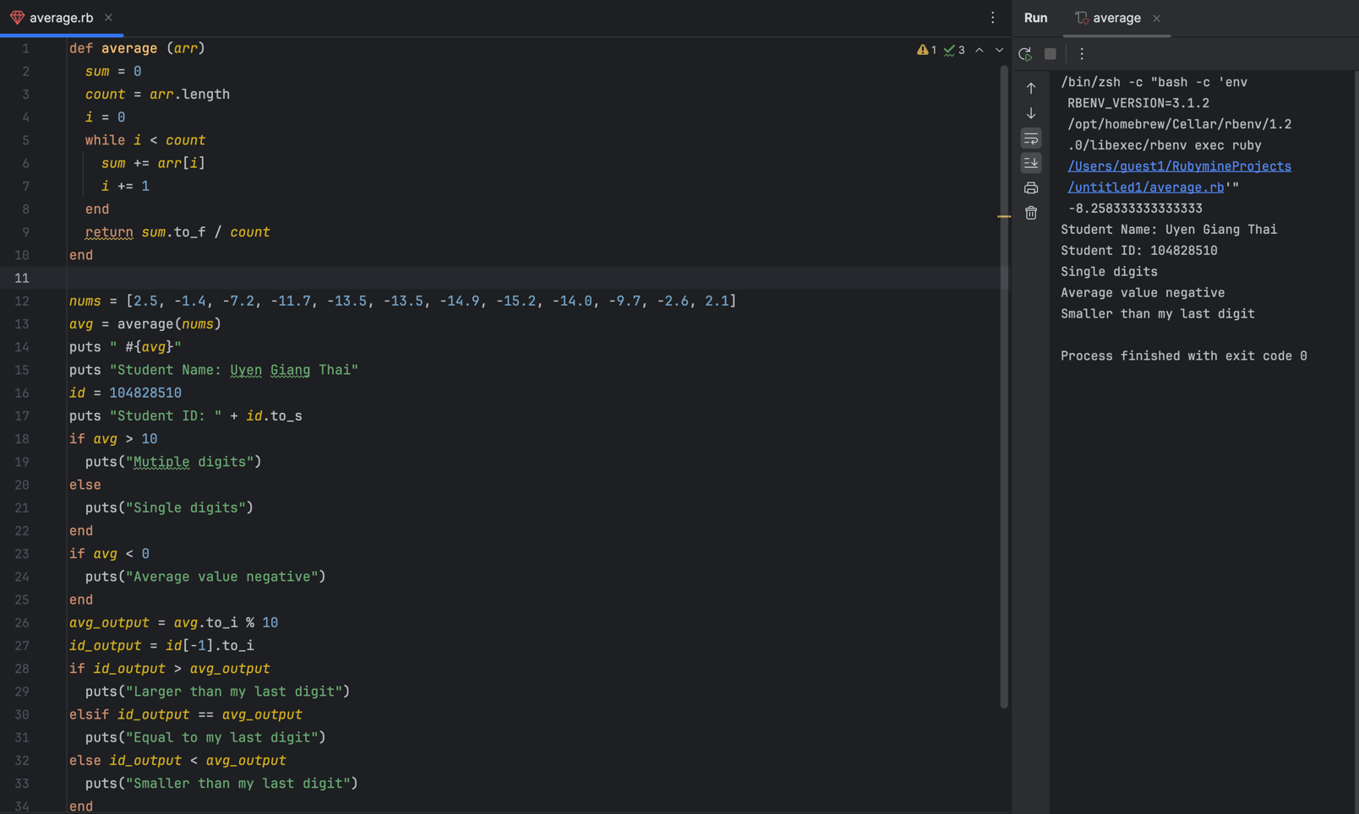*Finally on a new page paste a SINGLE screenshot of your program (mainline and function) running with its outputs here:*

# End of Task

**Please render your paper as a PDF and submit via CANVAS.**